Name: Prof. Dr. Panchsheela Ashok Ubale
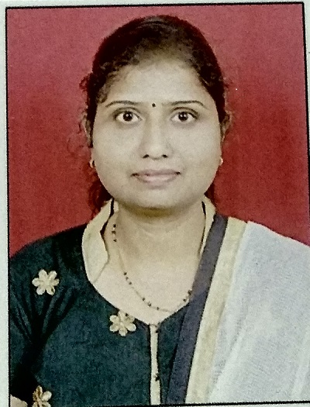Photo
Designation: Assistant Professor
Qualification: M.Sc.(Organic Chemistry), Ph.D.
Age: 38 Years
Experience: 17 Years
Email Id: panchsheelaubale@orchidengg.ac.in
Area of Interest: Bioinorganic Chemistry
Organic Chemistry
Materials Chemistry
Publications:
1. International Conference: 02
2. National Conference:01
3. International Journal: 09
4. National Journal: Nil
Subject Taught:
1. Engineering Chemistry

Awards & Recognition:
Received Best Teacher Award in General Engineering Department in 2020.
Achievements:
Received 1st price to poster in international conference on “Chemical and Environment Interface” organizes by Department of Chemistry,Arts , Commerce and Science College, Lanja, Dist: Ratnagiri
Conferences / STTP / Workshops
Conference-10
STTP- 03
FDP-03
Workshops- 04
Committee Member:
1) Standing Committee Member
2) Secretory of Internal Complaint Committee
Professional Memberships:
1) ISTE member

